LAB 1

Question 1 : Add Two Numbers

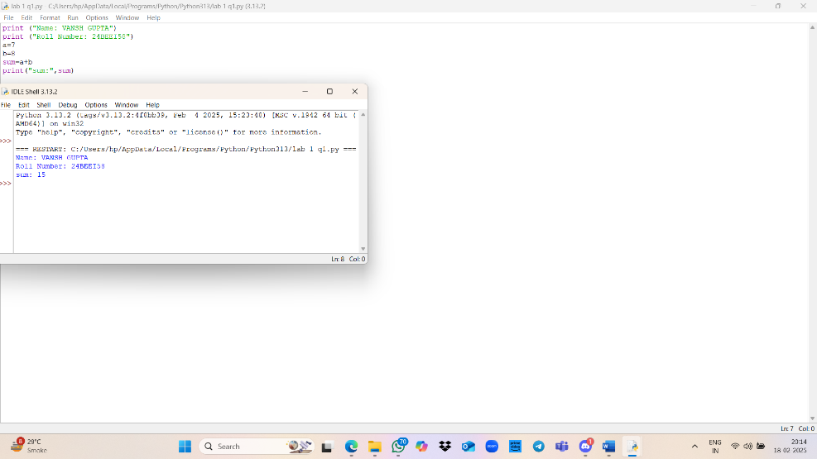

Question 2: Subtract Two Numbers

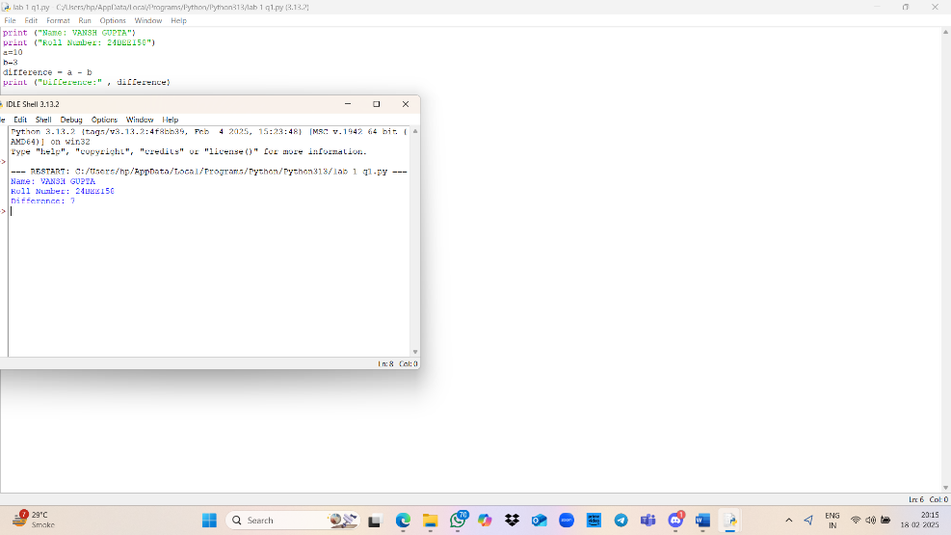

Question 3: Multiply Two Numbers

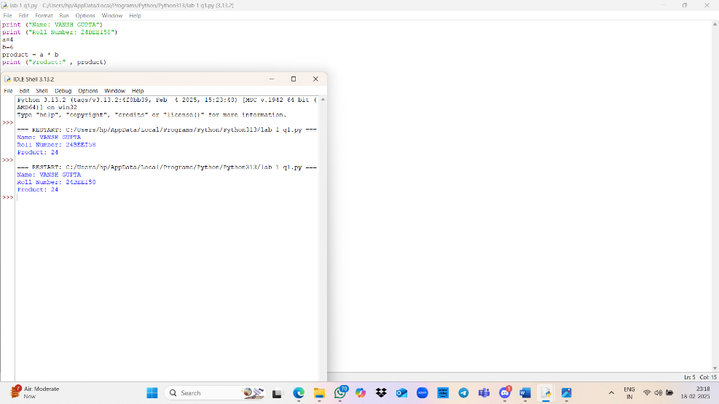

Question 4: Divide Two Numbers

|  |
| --- |
|  |

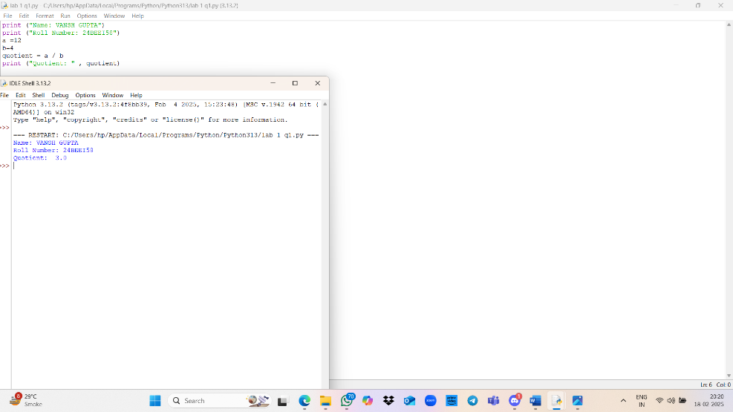Question 5: Add, Multiply, Subtract, and Divide Two Numbers

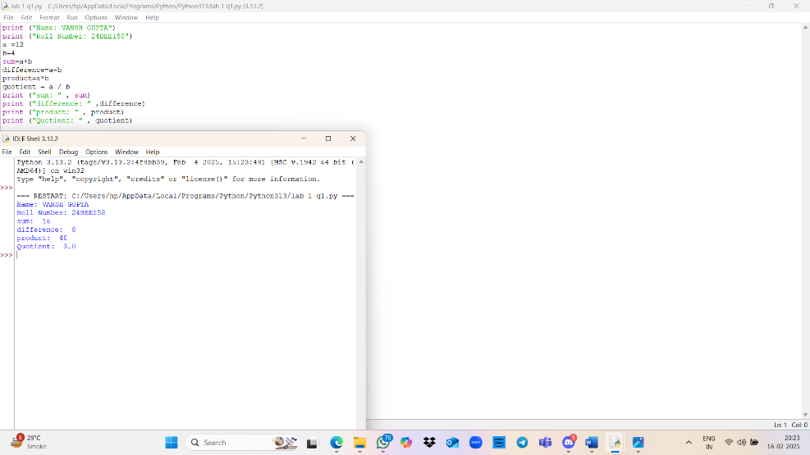Question 6: Conve rt Hours into Minutes 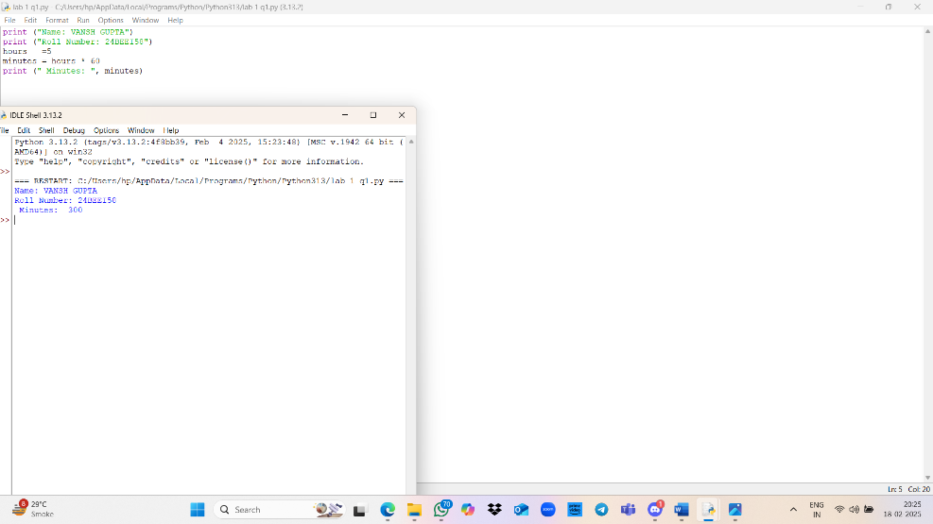

|  |
| --- |
|  |

7: Minutes Hours

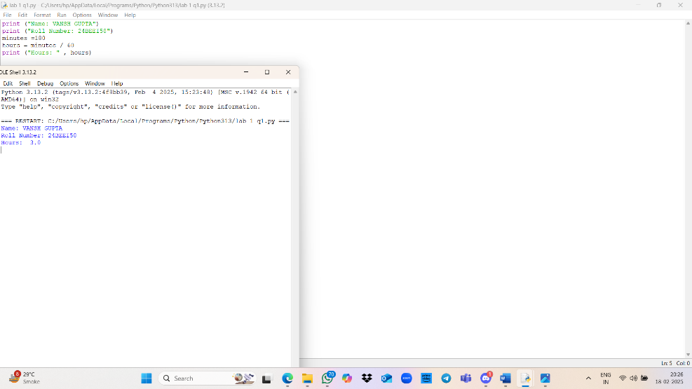 Question 8: Convert Dollars into Rupees (l $ = 48 Rs)

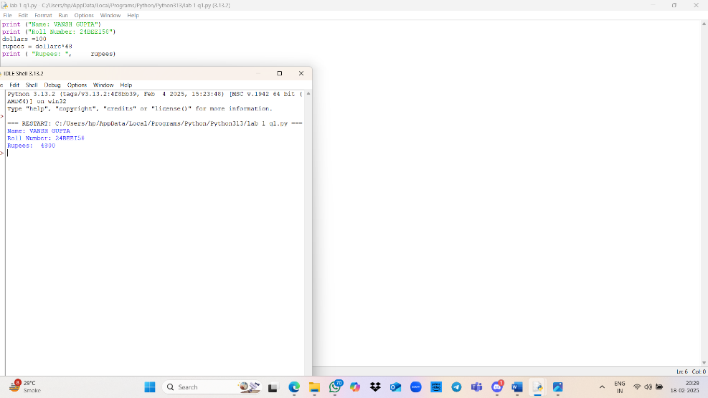

Question 9: Convert Rupees into Dollars (l $ = 48 Rs)

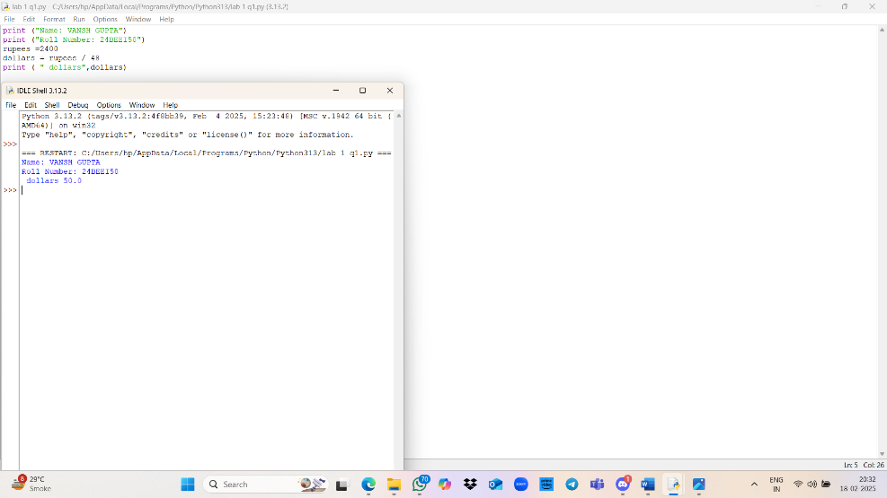

Dollars Pounds (1 $ = 48 Rs, I Pound 70 rs R

|  |
| --- |
|  |

Question 11: Convert Grams into Kilograms

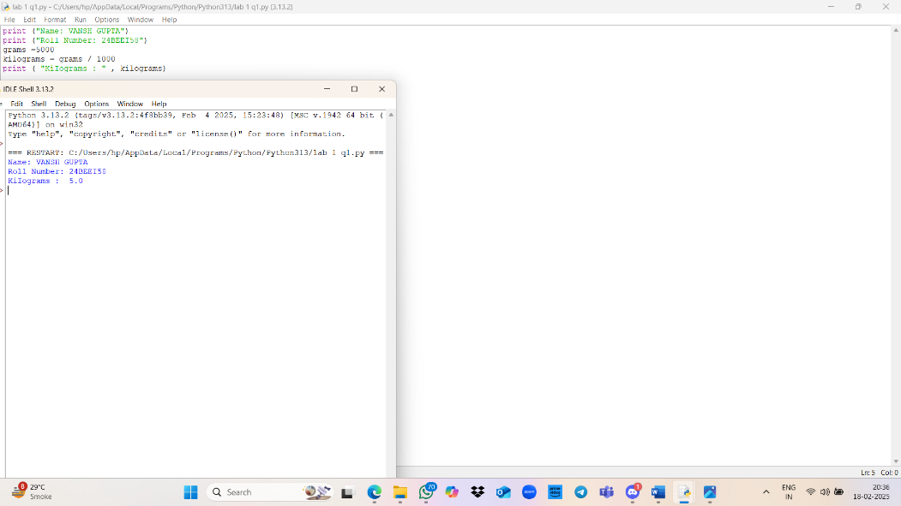

|  |
| --- |
|  |

Question 12: Convert Kilograms into Grams

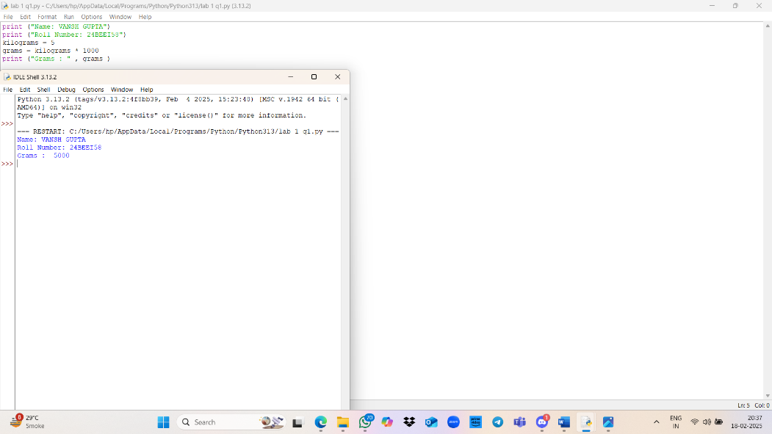

QUESTION 13: Bytes INTO KB, MB, and GB

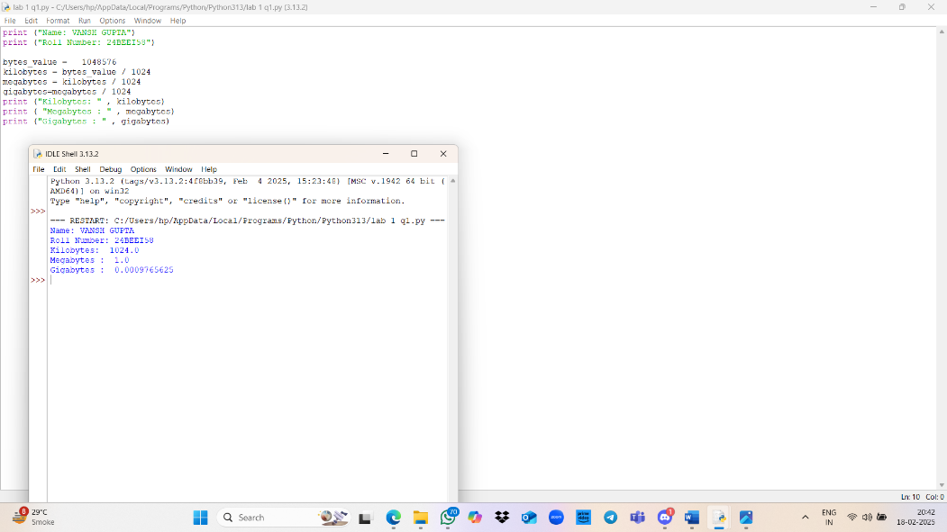

Question 14: Convert Celsius into Fahrenheit (F (9/5 * C) + 32) 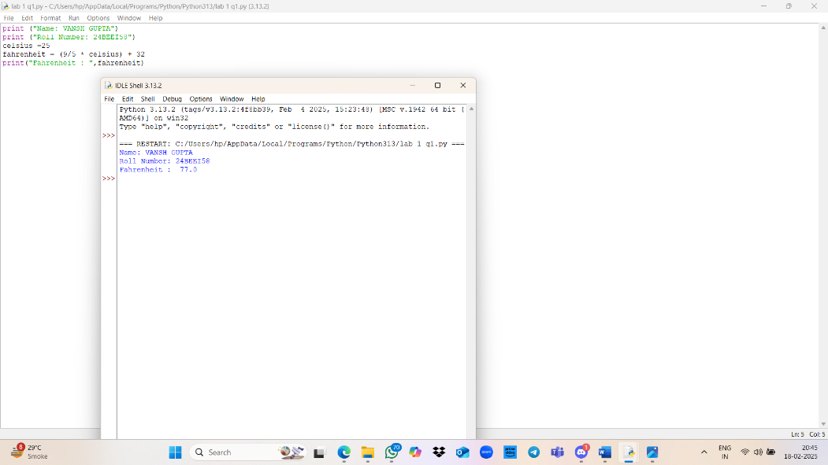



Question 15: Convert Fahrenheit into Celsius (C = 5/9 * (F — 32)) Interest (I — PRN/ 100)

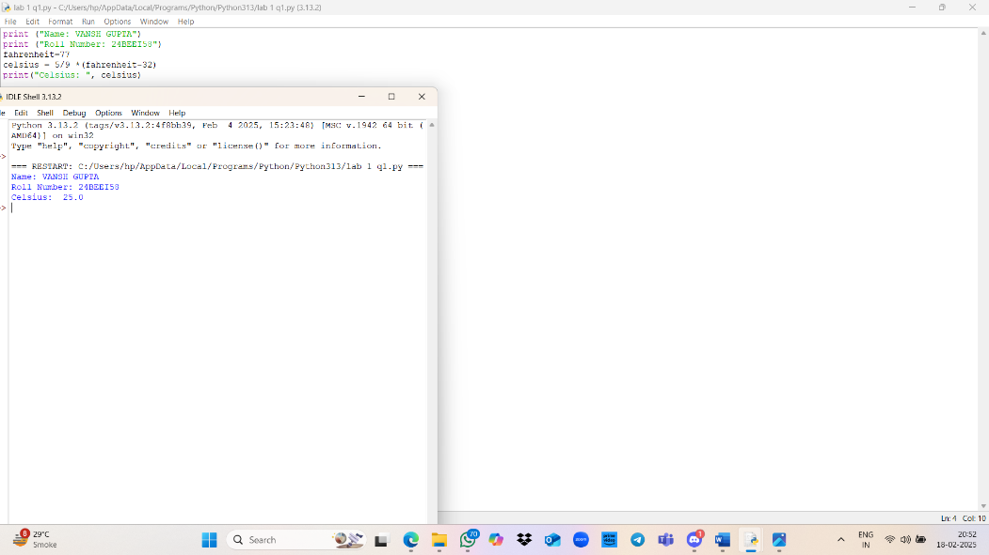

QUESTION 16: CALCULATE INTEREST

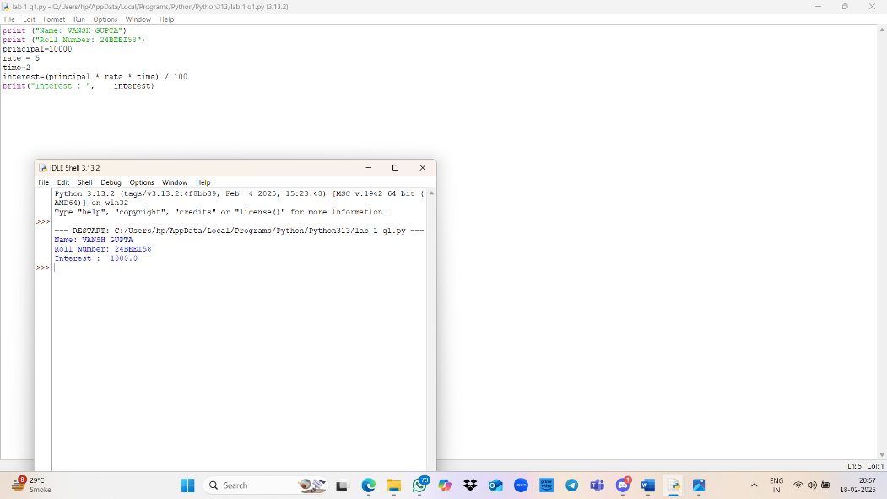

Question 17: Calculate Area and Perimeter of a Square (A- LA24L)

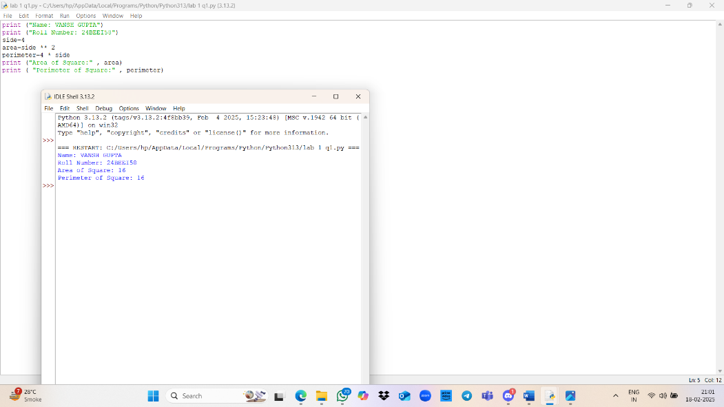

Question 1 8: Calculate Area and Perimeter of a Rectangle (A P = 2(L+B)))

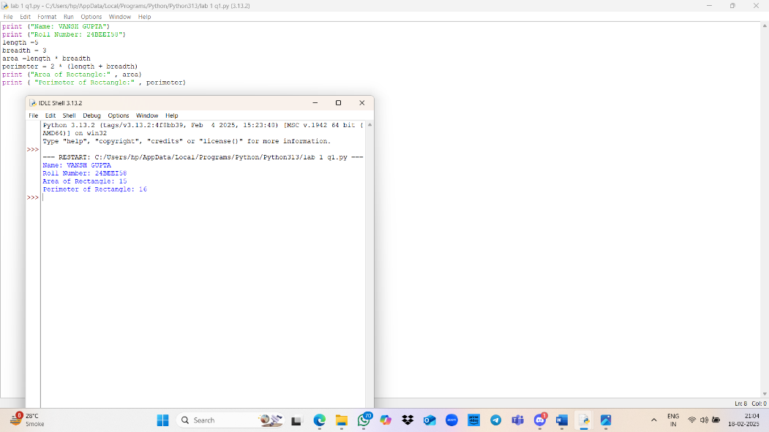

Question 2 Area of a Circle (A 22/7 * R * R)

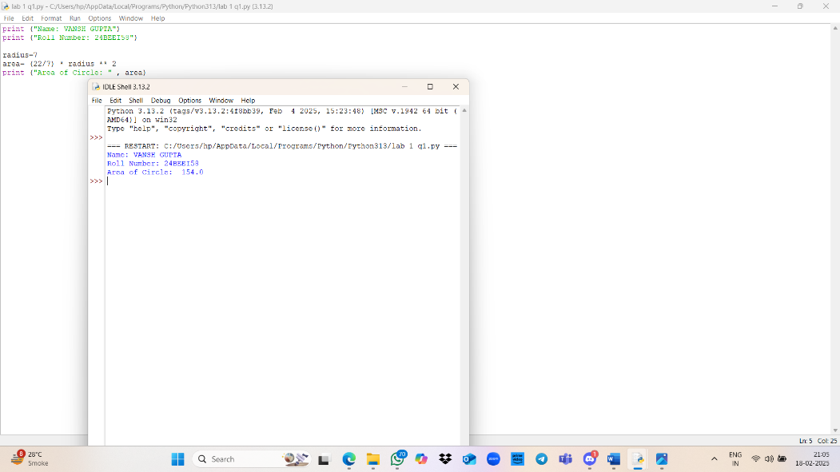

Question 20: Calculate Area of a Triangle (A H * L / 2)

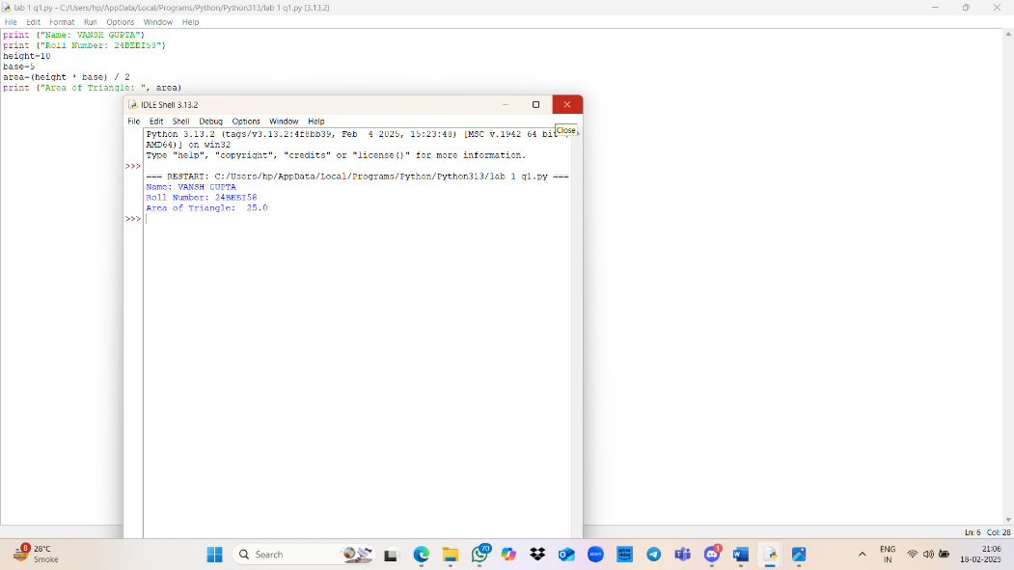

Question 21: Calculate Net Salary (net salary gross salary + allowance - deduction)

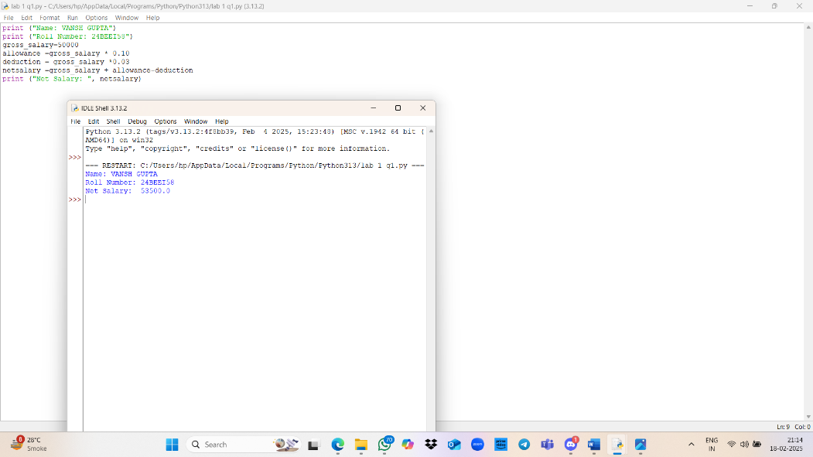

22: Net Sales (net sales gross sales - 10% discount of gross sales)

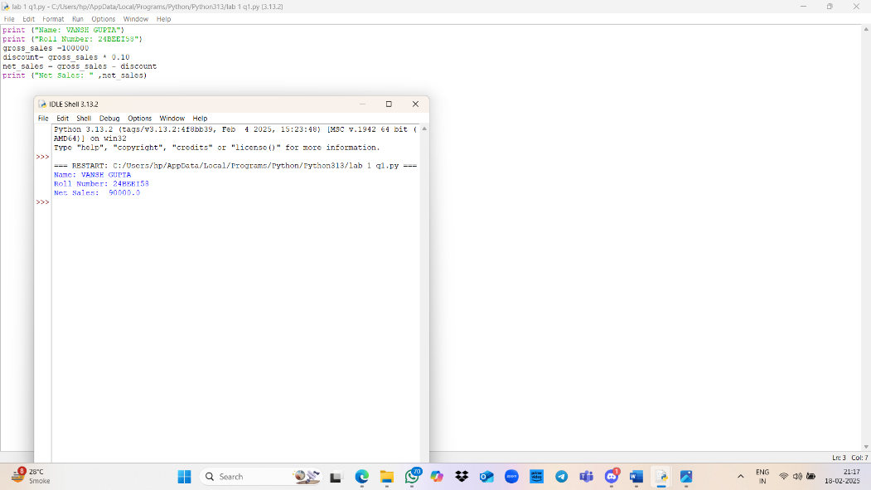

Question 23: Calculate Average of Three Subjects Along with Their Total

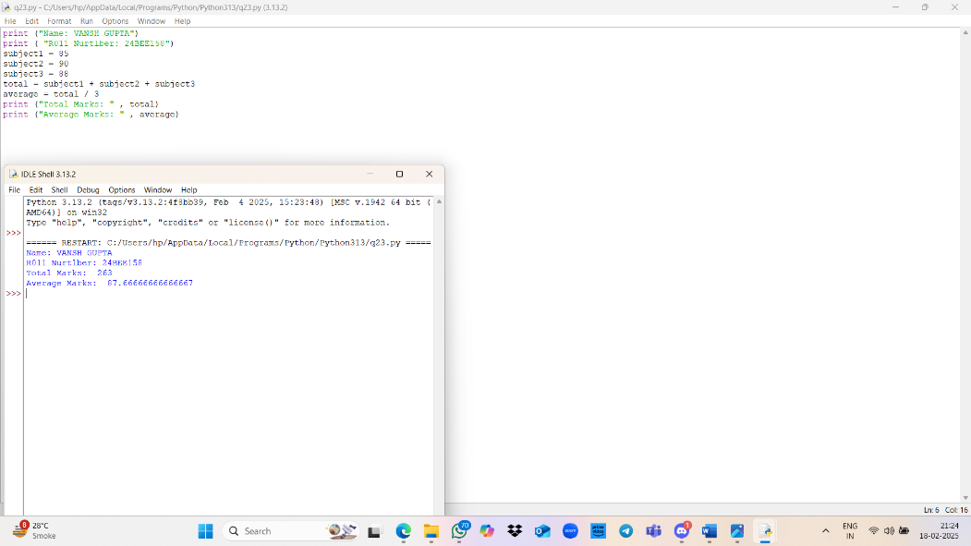

Question 24: Swap Two Values

